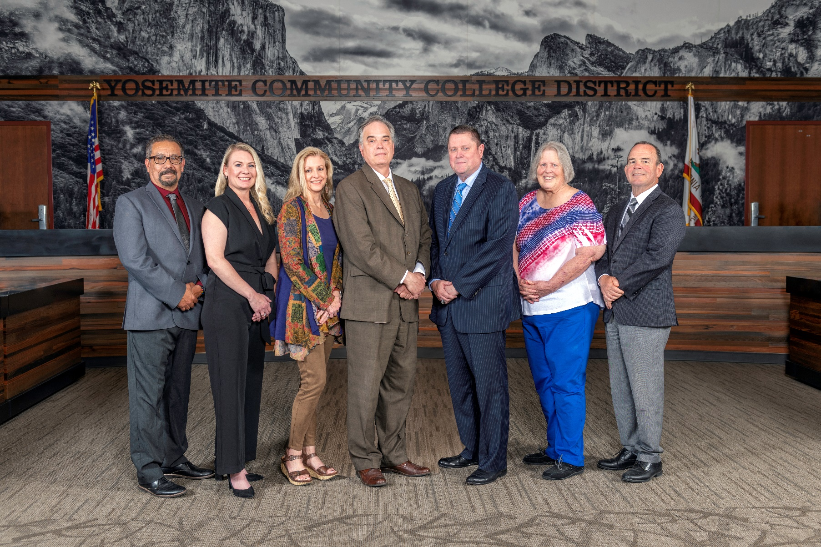

**Board Meeting Highlights**

**September 10, 2025**

**Regular Board Meeting**

**Report Out from Closed Session**

There was no report out from Closed Session.

**Board Committee Report: Board Finance Committee Report**

Trustee Darin Gharat provided the Board of Trustees with an update from the Board Finance Committee.

**Board Committee Report: Columbia College Foundation Report**

Trustee Don Davis provided the Board of Trustees with an update from the Columbia College Foundation.

**Board Committee Report: Association of Stanislaus County School Boards Report**

Trustee Don Davis provided the Board of Trustees with an update from the Association of Stanislaus County School Boards.

**Board Committee Report: Valley Insurance Program/Joint Powers Agency Board Report**

Trustee Darin Gharat provided the Board of Trustees with an update from the Valley Insurance Program/Joint Powers Agency Board.

**Presentation: MJC’s 2023-2028 Strategic Plan Progress Report – August 2025 Measurement Update**

Caterina Grossi, MJC Director of College Research & Planning, provided the Board of Trustees with an update on MJC’s progress toward meeting the goals set out in the College’s Strategic Plan, Education Master Plan, and Institution-Set Standards.

**Interim Chancellor Update**

Interim Chancellor Tran congratulated Luisa Adams on her retirement, expressing gratitude for her dedication and service. Dr. Tran also thanked the CSEA members for their introductions and recognized the commitment of the Caring Campus team, specifically acknowledging Amanda Cannon.

Dr. Tran took the opportunity to attend West Fest and Welcome Day at Modesto Junior College, highlighting the valuable contributions of the Classified Professionals. Dr. Tran expressed appreciation for everyone’s efforts during the successful Welcome Week activities, noting that everyone’s hard work enriches the campus community. Dr. Tran enjoyed getting to know the community and participating in the campus culture.

Additionally, Dr. Tran invited and encouraged everyone to attend the upcoming State of the District event on September 24th.

Finally, Dr. Tran invited Dr. Sanders to provide the Board of Trustees with an update on Modesto Junior College.

**YCCD Personnel Transaction**

The Board of Trustees acknowledged and commended the following retiree(s) for their years of service to the District:

       o   Maria ‘Luisa’ Adams, Library Specialist (21 years)

**2025-2026 Yosemite Community College District Final Budget**

The Board of Trustees conducted a public hearing regarding the 2025-2026 Final Budget for the Yosemite Community College District, adopted the District’s 2025-2026 Final Budget, and authorized staff to prepare and file the necessary annual Financial and Budget Report (CCFS 311) with the required agencies.

**Personnel – Negotiations YFA/YCCD – MOU’s**

The Board of Trustees approved the Memoranda of Understanding agreements reached for the 2024-2025 Reopener contract negotiations, which fully resolved the 2024-2025 Reopener negotiations and memorialized the MJC RSI Compliance and off-cycle review (“RSI MOU”).

**Out-of-Country Travel – Modesto Junior College – Abu Dhabi, United Arab Emirates**

The Board of Trustees approved the out-of-country travel for Modesto Junior College Instructor of Child Development, Dr. Brandon Gilbert, to attend and present at the 2025 Bright Start International Conference – Early Years Excellence in Abu Dhabi, United Arab Emirates, from November 10-16, 2025.

**Next Meetings**

The next regular meeting of the Board of Trustees will be held on October 8, 2025. Closed Session will begin at 3:00 p.m. and Open Session at 5:30 p.m. at Columbia College, 11600 Columbia College Drive, Sonora, California.

***All Board action is available on BoardDocs following the meeting at this link:*** [https://go.boarddocs.com/ca/yosemite/Board.nsf/vpublic?open](https://nam02.safelinks.protection.outlook.com/?url=https%3A%2F%2Fgo.boarddocs.com%2Fca%2Fyosemite%2FBoard.nsf%2Fvpublic%3Fopen&data=05%7C02%7Cgibbsk%40yosemite.edu%7C04ab26527f6a495a1c8e08dce989f34c%7C3d35afe626ac437eb4b375b50d459e45%7C0%7C0%7C638642026033239352%7CUnknown%7CTWFpbGZsb3d8eyJWIjoiMC4wLjAwMDAiLCJQIjoiV2luMzIiLCJBTiI6Ik1haWwiLCJXVCI6Mn0%3D%7C0%7C%7C%7C&sdata=LemRImXBecA5B4HggjFShKy2x6iWsE3ViNf%2BdE6cGew%3D&reserved=0)