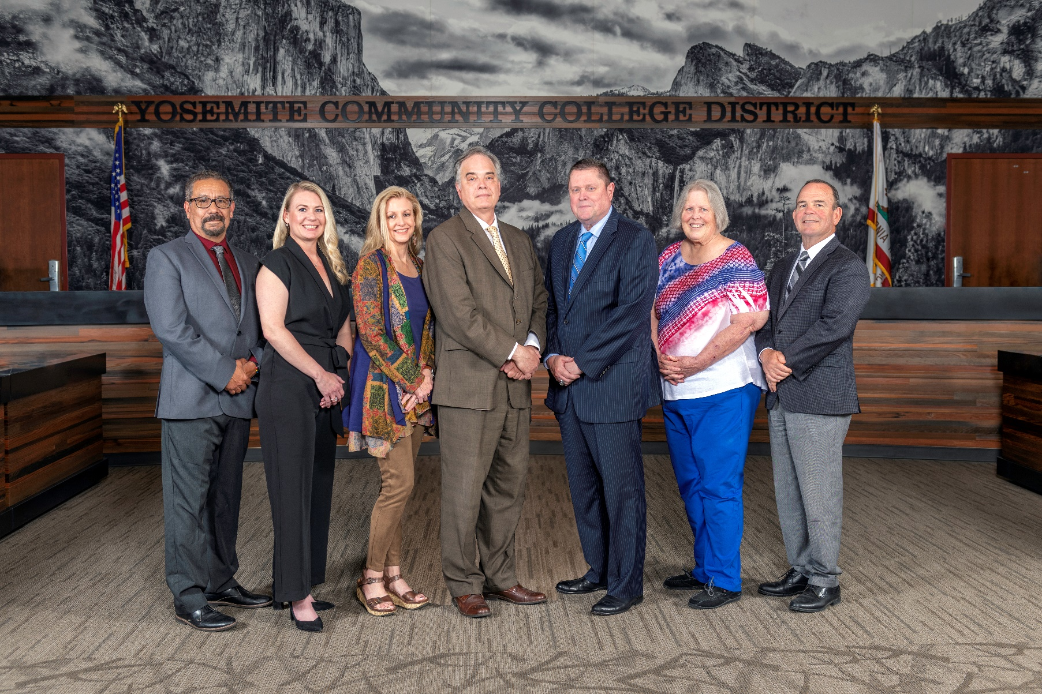

**Board Meeting Highlights**

**October 8, 2025**

**Regular Board Meeting**

**Report Out from Closed Session**

There was no report out from Closed Session.

**Board Committee Report: Modesto Junior College Foundation Report**

Trustee Leslie Beggs provided the Board of Trustees with an update from the Modesto Junior College Foundation.

**Board Committee Report: Columbia College Foundation Report**

Trustee Don Davis provided the Board of Trustees with an update from the Columbia College Foundation.

**Interim Chancellor Update**

Interim Chancellor Tran recognized and acknowledged her staff, Graciela Molina and Kimberly Gibbs, for being present at the Board meeting. She thanked them for their dedication and commitment to the District, which was demonstrated by their presence at the meeting given their family emergencies.

Finally, Dr. Tran invited Dr. Sanders and Dr. Redwing to provide the Board of Trustees with an update from their respective colleges.

**YCCD Personnel Transaction**

The Board of Trustees acknowledged and commended the following retiree(s) for their years of service to the District:

o   Michael Akard, Professor of English as a Second Language (ESL) (25 years)

o   Vicki Fontana, Senior Accountant (12 years)

o   Marcos Garcia, Counselor (35 years)

o   David Shrock, Professor of Health Education (29 years)

       o   James Thomas, Network Analyst (11 years)

**Modesto Junior College Proposed Curriculum Changes**

The Board of Trustees approved the curriculum additions, deletions, and modifications as indicated on the Proposed Curriculum Changes Report for the September 9, 2025, Curriculum Committee meeting.

**Modesto Junior College Sabbatical Leave Report**

The Board of Trustees accepted the 2024-2025 Sabbatical Leave Report from the following Modesto Junior College faculty member:

       o   Debra Bolter – Fall 2024 – Spring 2025

**Voting Delegates to the 2025 ACCT Leadership Congress**

The Board of Trustees appointed Dr. Don Davis to serve as the voting delegate for the 2025 ACCT Leadership Congress in New Orleans, LA.  The Board of Trustees also identified Trustee Antonio Aguilar to serve as the alternate voting delegate should the voting delegate be unable to carry out the duties.

**YCCD Resolution No. 25-26.03 – Resolution Authorizing Continued Funding Application**

The Board of Trustees adopted YCCD Resolution No. 25-26.03 in the Matter of Resolution Authorizing Continued Funding Application.

**Personnel – Negotiations Reopener, YCCD/YFA**

The Board of Trustees acknowledged receipt of YFA’s and YCCD’s collective bargaining proposal reopeners; scheduled the public comment on the proposals and Board approval of the District’s proposal for November 12, 2025; and referred the proposals to administrative staff for review.

**Personnel – Approval of Addendum Employment Contract for Interim Chancellor, Yosemite Community College District**

The Board of Trustees approved the addendum employment contract for the Interim Chancellor, Yosemite Community College District.

**Next Meetings**

The next regular meeting of the Board of Trustees will be held on November 12, 2025. Closed Session will begin at 3:00 p.m. and Open Session at 5:30 p.m. at Columbia College, 11600 Columbia College Drive, Sonora, California.

***All Board action is available on BoardDocs following the meeting at this link:*** [https://go.boarddocs.com/ca/yosemite/Board.nsf/vpublic?open](https://nam02.safelinks.protection.outlook.com/?url=https%3A%2F%2Fgo.boarddocs.com%2Fca%2Fyosemite%2FBoard.nsf%2Fvpublic%3Fopen&data=05%7C02%7Cgibbsk%40yosemite.edu%7C04ab26527f6a495a1c8e08dce989f34c%7C3d35afe626ac437eb4b375b50d459e45%7C0%7C0%7C638642026033239352%7CUnknown%7CTWFpbGZsb3d8eyJWIjoiMC4wLjAwMDAiLCJQIjoiV2luMzIiLCJBTiI6Ik1haWwiLCJXVCI6Mn0%3D%7C0%7C%7C%7C&sdata=LemRImXBecA5B4HggjFShKy2x6iWsE3ViNf%2BdE6cGew%3D&reserved=0)