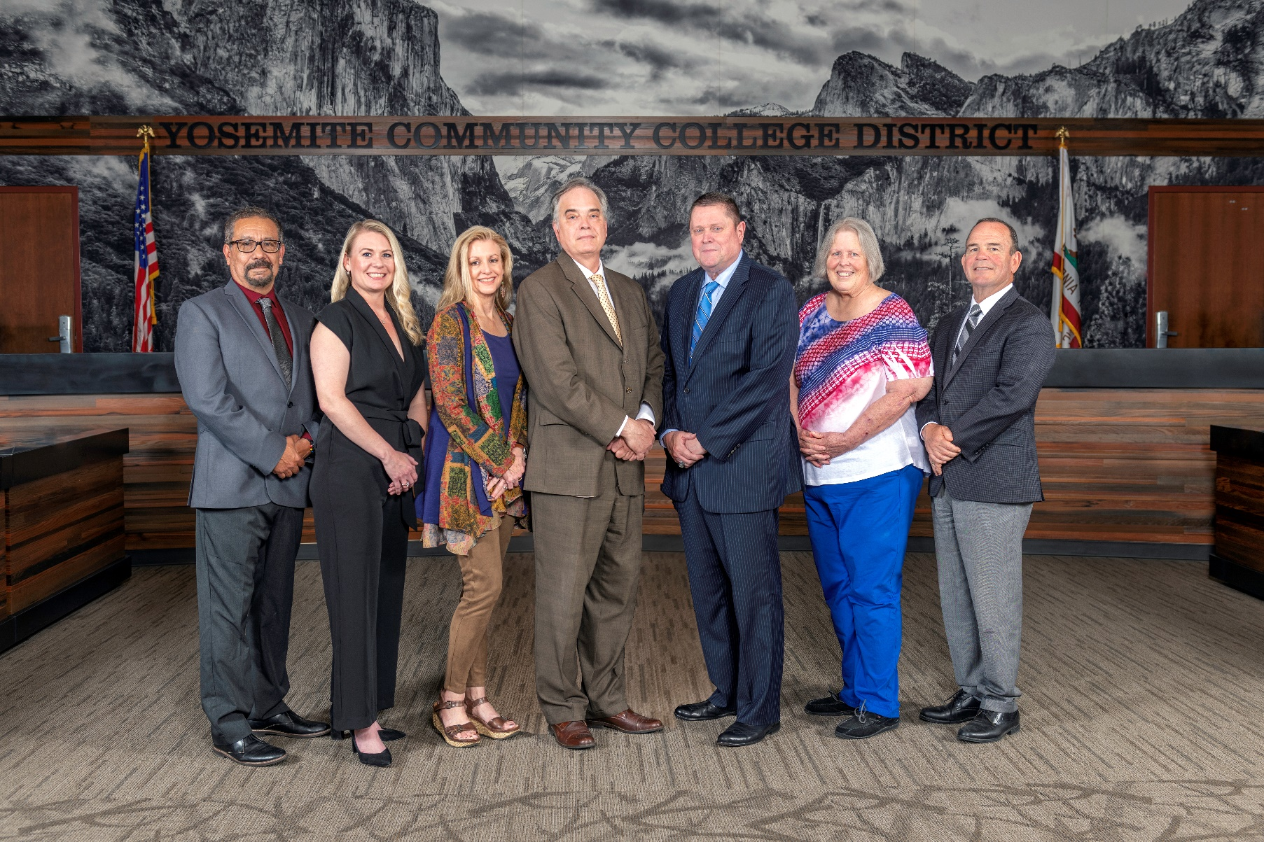

**Board Meeting Highlights**

**July 9, 2025**

**Regular Board Meeting**

**Report Out from Closed Session**

Board President Milton Richards read the following:

*“In closed session, the Board took action to approve a resignation and release agreement. The vote was unanimous.”*

**New YCCD Student Trustee**

Matthew Gutierrez, of Modesto Junior College, was sworn in as the new 2025-2026 YCCD Student Trustee.

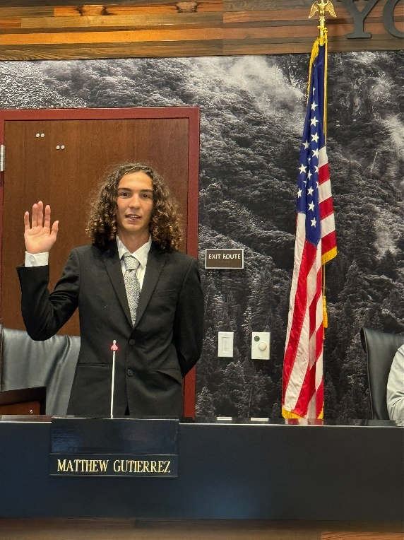

**Board Committee Report: Modesto Junior College Foundation Report**

Trustee Leslie Beggs provided the Board of Trustees with an update from the Modesto Junior College Foundation.

**Interim Chancellor Update**

Interim Chancellor Tran invited Dr. Sanders to provide the Board of Trustees with an update on Modesto Junior College.

Interim Chancellor Tran also invited Lucus Bogle, Vice Chancellor of Information Technology and Institutional Research, to provide the Board of Trustees with a briefing on the current and future state of IT.

**YCCD Personnel Transaction**

The Board of Trustees acknowledged and commended the following retiree(s) for their years of service to the District:

* Margie Humphres, Professor of Nursing (6 years)

**Out-of-Country Travel – Modesto Junior College – Canadian Track and Field Championships**

The Board of Trustees approved the out-of-country travel for Modesto Junior College student Shaylan Roy-Williams and Coach Brian Beeman to attend and compete in the Canadian Track and Field Championships from July 30, 2025, to August 1, 2025.

**Personnel – Approval of Employment Contract for Interim President, Columbia College**

The Board of Trustees approved the appointment and employment contract for the Interim President, Columbia College.

**Personnel – Approval of Employment Contract for Associate Vice Chancellor, Human Resources**

The Board of Trustees approved the employment contract for the Associate Vice Chancellor, Human Resources.

**Next Meetings**

The next regular meeting of the Board of Trustees will be held on August 13, 2025.  Closed Session will begin at 3:00 p.m. and Open Session at 5:30 p.m. in the Yosemite Community College District Board Room, 2201 Blue Gum Avenue, Modesto, California.

***All Board action is available on BoardDocs following the meeting at this link:*** [https://go.boarddocs.com/ca/yosemite/Board.nsf/vpublic?open](https://nam02.safelinks.protection.outlook.com/?url=https%3A%2F%2Fgo.boarddocs.com%2Fca%2Fyosemite%2FBoard.nsf%2Fvpublic%3Fopen&data=05%7C02%7Cgibbsk%40yosemite.edu%7C04ab26527f6a495a1c8e08dce989f34c%7C3d35afe626ac437eb4b375b50d459e45%7C0%7C0%7C638642026033239352%7CUnknown%7CTWFpbGZsb3d8eyJWIjoiMC4wLjAwMDAiLCJQIjoiV2luMzIiLCJBTiI6Ik1haWwiLCJXVCI6Mn0%3D%7C0%7C%7C%7C&sdata=LemRImXBecA5B4HggjFShKy2x6iWsE3ViNf%2BdE6cGew%3D&reserved=0)