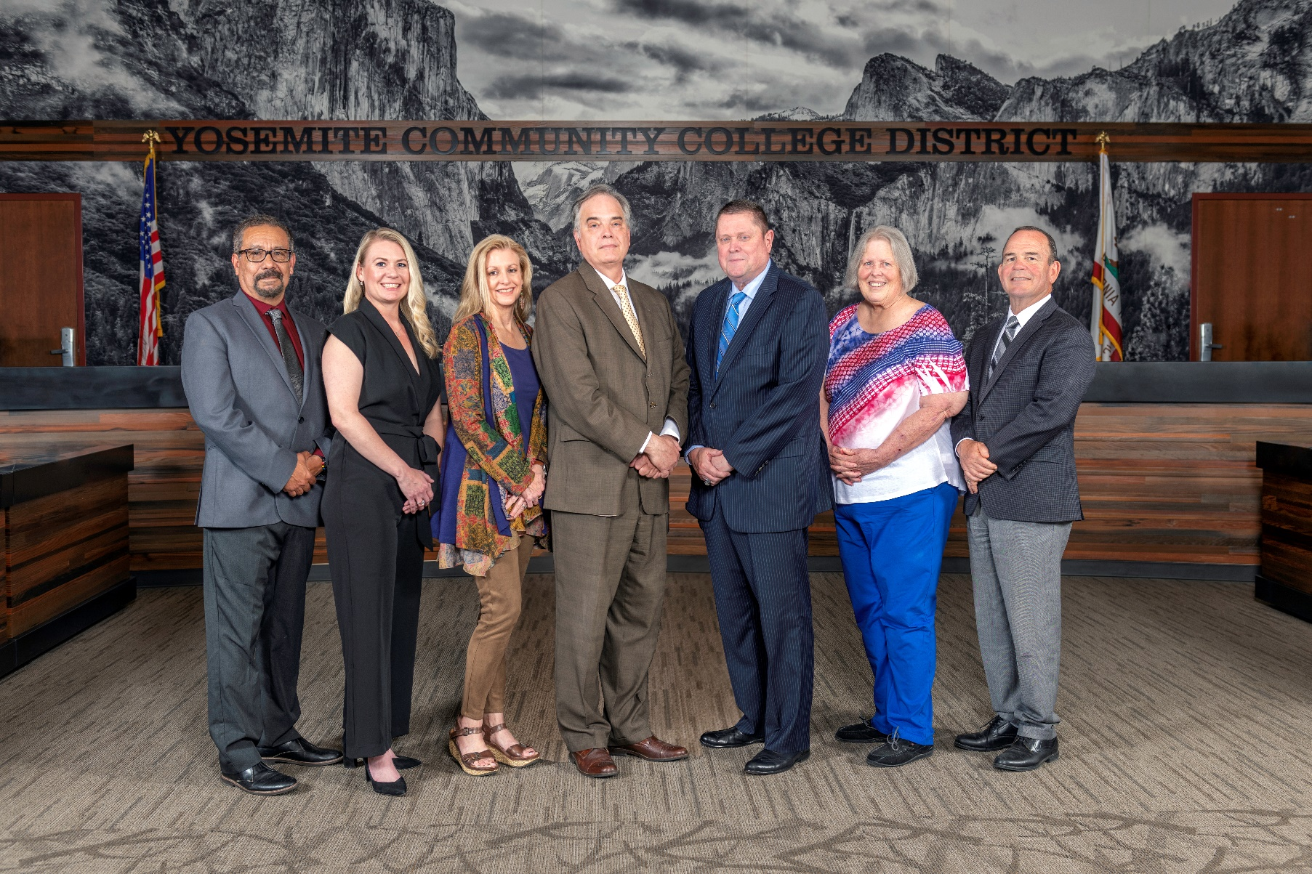

**Board Meeting Highlights**

**May 14, 2025**

**Regular Board Meeting**

**Report Out from Closed Session**

Board Stenographer Graciela Molina read the following:

*“In closed session, the Board voted unanimously to approve the Notice of Intent to Dismiss and the Statement of Charges against a permanent faculty employee.”*

**Board Committee Report: Modesto Junior College Foundation Report**

Trustee Leslie Beggs provided the Board of Trustees with an update from the Modesto Junior College Foundation.

**Board Committee Report: Association of Stanislaus County School Boards Report**

Trustee Don Davis provided the Board of Trustees with an update from the Association of Stanislaus County School Boards.

**Board Committee Report: Valley Insurance Program/Joint Powers Agency Report**

Trustee Darin Gharat provided the Board of Trustees with an update from the Valley Insurance Program/Joint Powers Agency.

**Chancellor Update**

Chancellor Yong invited Dr. Tran and Dr. Sanders to provide the Board of Trustees with an update from their respective colleges.

Chancellor Yong recognized the faculty, staff, and administrators at both colleges for their efforts in holding successful commencement ceremonies. Chancellor Yong also thanked the Facilities team, specifically the grounds and custodial staff members, and the Campus Safety team for the work they provided during both events.

**Chancellor Update Continued**

Chancellor Yong reminded everyone that, in appreciation of Classified School Employees’ Week, May 18-24, the District will be providing celebrations in honor of our classified professionals on the following dates and times:

o   Monday, May 19, 11:30 am-12:30 pm, Columbia College

o   Tuesday, May 20, 8:30 am-9:30 am, Modesto Junior College, East Campus

o   Tuesday, May 20, 1:00 pm-2:00 pm, District Office/Modesto Junior College, West Campus

       o   Tuesday, May 20, 8:30 pm, Custodial Break Room and Security Break Room, East & West Campus

Chancellor Yong announced that the Board of Trustees selected Jacquelin Wingett, MJC Senior Administrative Secretary in the Arts, Humanities & Communications, as the YCCD nomination for the Classified Employee of the Year Award.  Jacquelin’s name has been submitted to the California Community Colleges Board of Governors and the Foundation for California Community Colleges.  The Board honored Jacquelin Wingett with an award presentation as the 2025 YCCD Classified Employee of the Year.

Finally, Chancellor Yong presented service awards to Gustavo Castrejon, Amanda Cannon, and Allan McKissick (who was not present at the meeting).

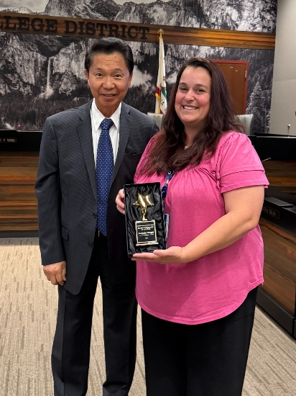 *The award was presented to Jacquelin Wingett for being selected as the 2025 YCCD Classified Employee of the Year.*

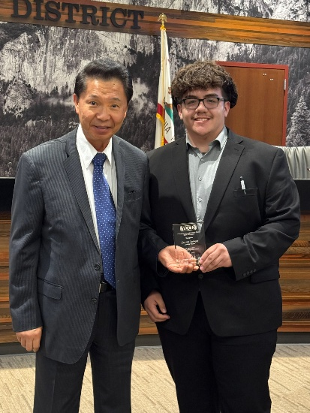 *The award was presented to Gustavo Castrejon for serving as the YCCD Student Trustee from 2024-2025.*

**Chancellor Update Continued**

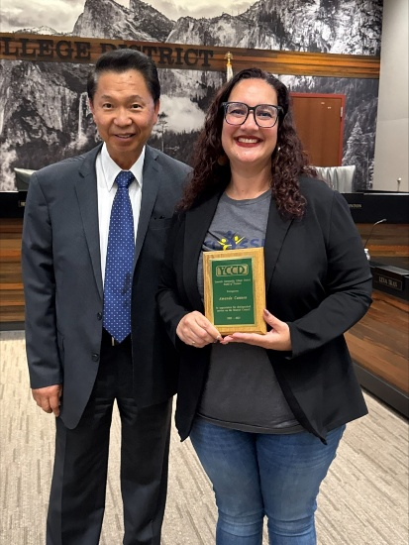 *The award was presented to Amanda Cannon for serving on the District Council from 2023-2025.*

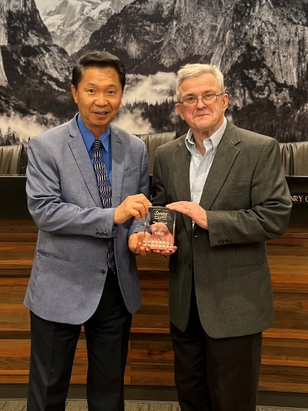  
*The award was presented to Allan McKissick for serving as the Faculty Liaison to the Board from 2017-2025 (photo taken earlier).*

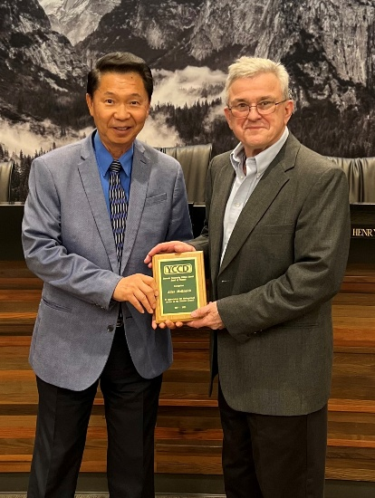*The award was presented to Allan McKissick for serving on the District Council from 2017-2025 (photo taken earlier).*

**Recognition of Dr. Henry C. V. Yong, Chancellor 2017-2025**

The Board of Trustees recognized Dr. Henry Chiong Vui Yong with an award in recognition of his lasting contribution as a loyal and committed Chancellor of the Yosemite Community College District. Throughout his tenure, Chancellor Yong has strengthened relationships between the colleges and the broader community, championed the expansion of dual enrollment within the District, led the District through times of uncertainty and challenge including the COVID-19 Pandemic, managing a faculty strike, leading through Presidential transitions and doing so consistently with integrity, compassion, and a clear focus on the well-being and success of students.

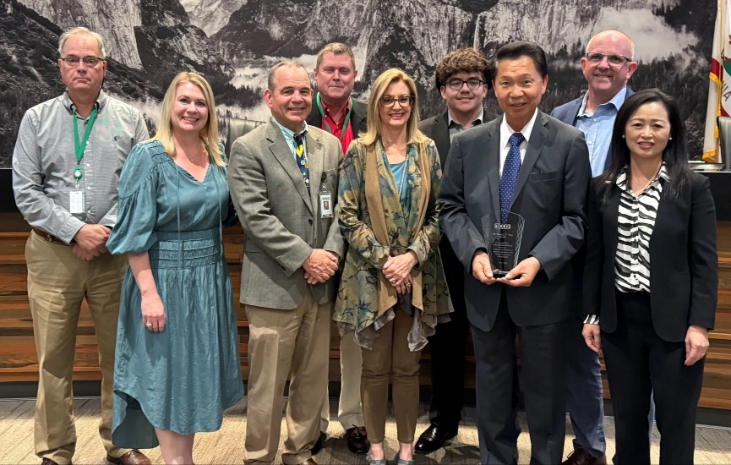*The award was presented to Dr. Henry Yong for serving as the YCCD Chancellor from 2017-2025.*

**Presentation: Modesto Junior College and Columbia College Financial Aid/Scholarships**

Aurelia Gonzalez, MJC Director of Student Financial Services, Dr. Emily Lawrence, MJC Executive Director of the MJC Foundation, Marnie Shively, Columbia College Director of Student Financial Services, and Amanda Stephens, Columbia College Director of Development, provided the Board of Trustees with an overview of the scholarship processes within the District in conjunction with state and federal requirements governing financial aid.

**Presentation: Columbia College Rising Scholars – Together We Rise**

Michelle Walker, Columbia College Director of External Initiatives, and James Coleman, Reimagining Myself Facilitator, provided the Board of Trustees with an overview of the Rising Scholars program and its growth over the last nine years.

**Columbia College Proposed Curriculum Changes**

The Board of Trustees approved the curriculum additions, deletions, and modifications as indicated on the Proposed Curriculum Changes Report for the period of March 18, 2025, to March 25, 2025.

**Modesto Junior College Proposed Curriculum Changes**

The Board of Trustees approved the curriculum additions, deletions, and modifications as indicated on the Proposed Curriculum Changes Reports for the March 25, 2025, and April 8, 2025, Curriculum Committee meetings.

**Modesto Junior College Sabbatical Leave Report**

The Board of Trustees accepted the 2024-2025 Sabbatical Leave Report from the following Modesto Junior College faculty members:

o   Shaila Christofferson – Fall 2024

o   Angelica Cortes – Fall 2024

       o   Tim Vaughan – Fall 2024

**Personnel – Approval of Employment Contract for Interim Chancellor, Yosemite Community College District**

The Board of Trustees approved Dr. Lena Tran’s appointment and employment contract for the Interim Chancellor, Yosemite Community College District.

**Next Meetings**

The next regular meeting of the Board of Trustees will be held on June 11, 2025.  Closed Session will begin at 3:00 p.m. and Open Session at 5:30 p.m. in the Yosemite Community College District Board Room, 2201 Blue Gum Avenue, Modesto, California.

***All Board action is available on BoardDocs following the meeting at this link:*** [https://go.boarddocs.com/ca/yosemite/Board.nsf/vpublic?open](https://nam02.safelinks.protection.outlook.com/?url=https%3A%2F%2Fgo.boarddocs.com%2Fca%2Fyosemite%2FBoard.nsf%2Fvpublic%3Fopen&data=05%7C02%7Cgibbsk%40yosemite.edu%7C04ab26527f6a495a1c8e08dce989f34c%7C3d35afe626ac437eb4b375b50d459e45%7C0%7C0%7C638642026033239352%7CUnknown%7CTWFpbGZsb3d8eyJWIjoiMC4wLjAwMDAiLCJQIjoiV2luMzIiLCJBTiI6Ik1haWwiLCJXVCI6Mn0%3D%7C0%7C%7C%7C&sdata=LemRImXBecA5B4HggjFShKy2x6iWsE3ViNf%2BdE6cGew%3D&reserved=0)