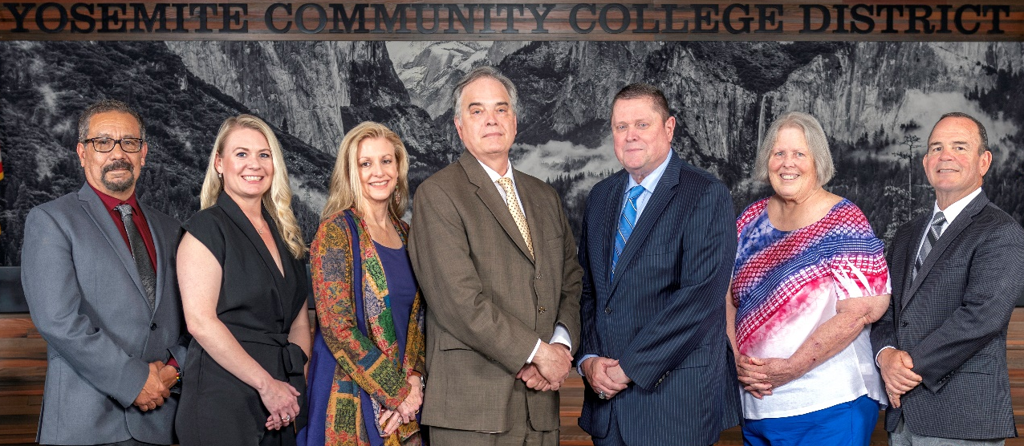
Board Meeting Highlights
April 8, 2026
Regular Board Meeting

Report Out from Closed Session
There was no report out from Closed Session.
Board Committee Report: Modesto Junior College Foundation Report
Trustee Leslie Beggs provided the Board of Trustees with an update from the Modesto Junior College Foundation.
Board Committee Report: Columbia College Foundation Report
Trustee Don Davis provided the Board of Trustees with an update from the Columbia College Foundation.
Interim Chancellor Update
Interim Chancellor Tran shared that it was wonderful to be back at Columbia College. She reported that work on the Strategic Plan continues to move forward. Dr. Tran also announced that the District has been awarded an IEPI grant focused on professional development. As part of this effort, Dr, Tran will host a team-building pickleball tournament in October, with mixed-constituency teams participating across the District, and encouraged everyone to begin preparing for the event.
Dr. Tran noted that the District is continuing to explore the possibility of a future bond measure. Surveys have been distributed, and the District is awaiting community feedback before determining next steps.
Finally, Dr. Tran invited Dr. Sanders and Dr. Redwing to provide the Board of Trustees with an update from their respective colleges.

Presentation: Columbia College Science Program
Colin Thomas, Instructor of Chemistry, provided the Board of Trustees with an update of the Columbia College Science Program. The presentation included program data that highlighted the successes of the department and the programmatic needs and future goals for the Physics and Chemistry Department.
Modesto Junior College Proposed Curriculum Changes
The Board of Trustees approved the curriculum additions, deletions, and modifications as indicated on the Proposed Curriculum Changes Reports for the February 10, 2026, February 24, 2026, and March 10, 2026, Curriculum Committee meetings.
Columbia College Proposed Curriculum Changes
The Board of Trustees approved the curriculum additions, deletions, and modifications as indicated on the Proposed Curriculum Changes Reports for the period of February 17, 2026, to March 3, 2026.
Modesto Junior College Faculty Tenure – 2026
The Board of Trustees approved that the following Modesto Junior College faculty members be granted tenure effective the beginning of the 2026-2027 academic year:
o Lindsay Bryan
o Travis Silvers
o Sara Tesfai
o Hans Hauselmann
o Dr. Mike Kersten
o Wendy McClendon
o Shawna Marinovich
o Alyssa Suarez
o John Davis
o Michael Ryun
o Eric Silva
o Tara Mello
o Andrew Lazar
o Jennifer (Jenni) Long
o Dr. M. Arthur White
Columbia College Faculty Tenure – 2026
The Board of Trustees approved that the following Columbia College faculty members be granted tenure effective the beginning of the 2026-2027 academic year:
o Juan Pablo Sanchez
o Jesse Ray
o Michael Keegan
o Rebekah Rogers
o Glen White
o Kimberly Montague

YCCD Personnel Transaction
The Board of Trustees acknowledged and commended the following retiree(s) for their years of service to the District:
o Erik Andal, Professor of Automotive Technology (30 years)
o Joe Galvan, Custodian (47 years)
o Erik Maki, Professor of Music/Director of Bands (21 years)
o Michael Torok, Professor of Biology (28 years)
Board Policy – 1st Reading
The Board of Trustees conducted a 1st reading on the following YCCD policies. All of the policies will be presented, as amended, to the Board for a 2nd reading at the May 13, 2026, Board Meeting.
o 2015 – Student Member
o 2110 – Vacancies on the Board
o 2310 – Regular Meetings of the Board
o 2340 – Agendas
o 2355 – Decorum
o 2410 – Board Policies and Administrative Procedures
o 3900 – Time, Place & Manner
o 6-8013 – Control of Fixed Assets
o 7150 – Evaluations
o 7340 – Leaves
o 7400 – Travel
Personnel – Executive Administrator Contract Renewal Vice Chancellor of Information Technology & Institutional Research
The Board of Trustees approved the Employment Contract for the Vice Chancellor of Information Technology & Institutional Research.
Personnel – Negotiations, YCCD/CSEA, Chapter 420 Tentative Agreement
The Board of Trustees approved the attached Tentative Agreement regarding salary, benefits, and contract language between the Yosemite Community College District (YCCD) and the California School Employees Association, Chapter 420 (CSEA), pending successful completion of CSEA’s ratification process.
YCCD Resolution No. 25-26.13 – Classified School Employee Week 2026
The Board of Trustees adopted Resolution No. 25-26.13 proclaiming May 17-23, 2026 as Classified School Employee Week in the Yosemite Community College District and thanked the YCCD classified staff for their commitment and contribution to the District.
YCCD Resolution No. 25-26.14 – Faculty Appreciation Week 2026
The Board of Trustees adopted Resolution No. 25-26.14 proclaiming May 5, 2026 as Faculty Appreciation Day and the week of May 4-8, 2026 to be Faculty Appreciation Week in the Yosemite Community College District and thanked the YCCD faculty for their commitment and contribution to the District.

Next Meetings
The next regular meeting of the Board of Trustees will be held on Wednesday, May 13, 2026. Closed Session will begin at 3:00 p.m. and Open Session at 5:30 p.m. in the Yosemite Community College District Board Room, 2201 Blue Gum Avenue, Modesto, California.

All Board action is available on BoardDocs following the meeting at this link: https://go.boarddocs.com/ca/yosemite/Board.nsf/vpublic?open

