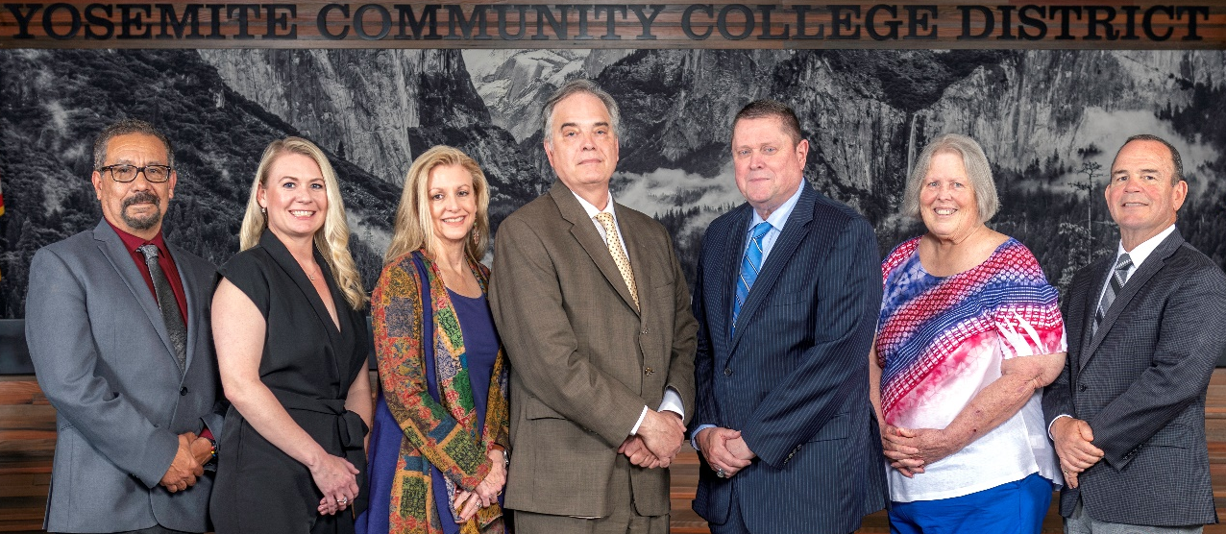
Board Meeting Highlights
March 11, 2026
Regular Board Meeting

Report Out from Closed Session
Board President Milton Richards read the following:
“In closed session, the Board took action to non-renew a classified administrator at the end of their current contract term on June 30, 2026 pursuant to Education Code Section 72411. The vote was unanimous.”
Board Committee Report: Modesto Junior College Foundation Report
Trustee Leslie Beggs provided the Board of Trustees with an update from the Modesto Junior College Foundation.
Interim Chancellor Update
Interim Chancellor Tran reported that the District Council has convened and has been designated as the committee responsible for developing the District Strategic Plan. She also shared that she plans to provide the Board of Trustees with monthly updates on the plan’s progress.
Dr. Tran noted that March is Women’s History Month and recognized all women, encouraging them to be strong, beautiful, and themselves.
She then invited Harry Davis, MJC Campus Safety Manager, to provide the Board of Trustees with updates on recent campus incidents.
Finally, Dr. Tran invited Dr. Sanders and Dr. Redwing to present updates from their respective colleges.

Presentation: Modesto Junior College Child Development Program
Michael Minnick, MJC Instructor of Child Development, and Gisele Flores, MJC Professor of Child Development, provided the Board of Trustees with an update on the MJC Child Development Department. The presentation highlighted the successes of the department, the students, and the growth of community partnerships.
Modesto Junior College Proposed Curriculum Changes
The Board of Trustees approved the curriculum additions, deletions, and modifications as indicated on the Proposed Curriculum Changes Report for the January 27, 2026, Curriculum Committee meeting.
YCCD Personnel Transaction
The Board of Trustees acknowledged and commended the following retiree(s) for their years of service to the District:
o Eileen Kerr, Professor of History (18 years)
o Alida Garcia, Counselor/Transfer Center Coordinator (36 years)
Board Policy – 2nd Reading
The Board of Trustees conducted a 2nd reading on the following YCCD policies and approved said policies as presented in the agenda.
o 3050 – Institutional Code of Ethics
o 3100 – Organizational Structure
o 3280 – Grants
o 3440 – Service Animals
o 3600 – Auxiliary Organizations
o 3810 – Claims Against the District
o 6-8015 – Grant Accounting
o 6-8064 – Special Purpose Grant Applications
CCCT Board of Directors Election - 2026
The Board of Trustees approved moving forward all nine candidates for the open nine seats on the CCCT Board of Directors as the single YCCD Board ballot to be submitted to the CCCT Board Elections Committee by the deadline.
Student Health Fee Increase
The Board of Trustees approved a health fee increase to $28 per semester and $23 per summer, effective summer 2026, for Modesto Junior College and Columbia College.
Nomination – State Board of Governors’ Annual Classified Employee of the Year Award
The Board of Trustees approved the selection of one YCCD Classified Staff member from the nominations to be submitted for the State Board of Governors and directed staff to forward that nomination to the Board of Governors and the Foundation for California Community Colleges (FCCC).

Personnel – Reduction in Force, Classified
The Board of Trustees approved YCCD Resolution No. 25-26.12, Reduction of District’s Classified, authorizing the elimination of three classified vacant positions.
Personnel – Executive Cabinet Contract Renewals
The Board of Trustees approved the Employment Contract Addendums for one year.
Personnel – Executive Cabinet Contract Renewals
The Board of Trustees approved the Employment Contract Addendums for two years.
Personnel – Approval of Addendum Employment Contract for Interim President, Columbia College
The Board of Trustees approved the addendum employment contract for the Interim President, Columbia College.
Next Meetings
The next regular meeting of the Board of Trustees will be held on Wednesday, April 8, 2026. Closed Session will begin at 3:00 p.m. and Open Session at 5:30 p.m. in the Manzanita Conference Room at Columbia College, 11600 Columbia College Drive, Sonora, California.

All Board action is available on BoardDocs following the meeting at this link: https://go.boarddocs.com/ca/yosemite/Board.nsf/vpublic?open

