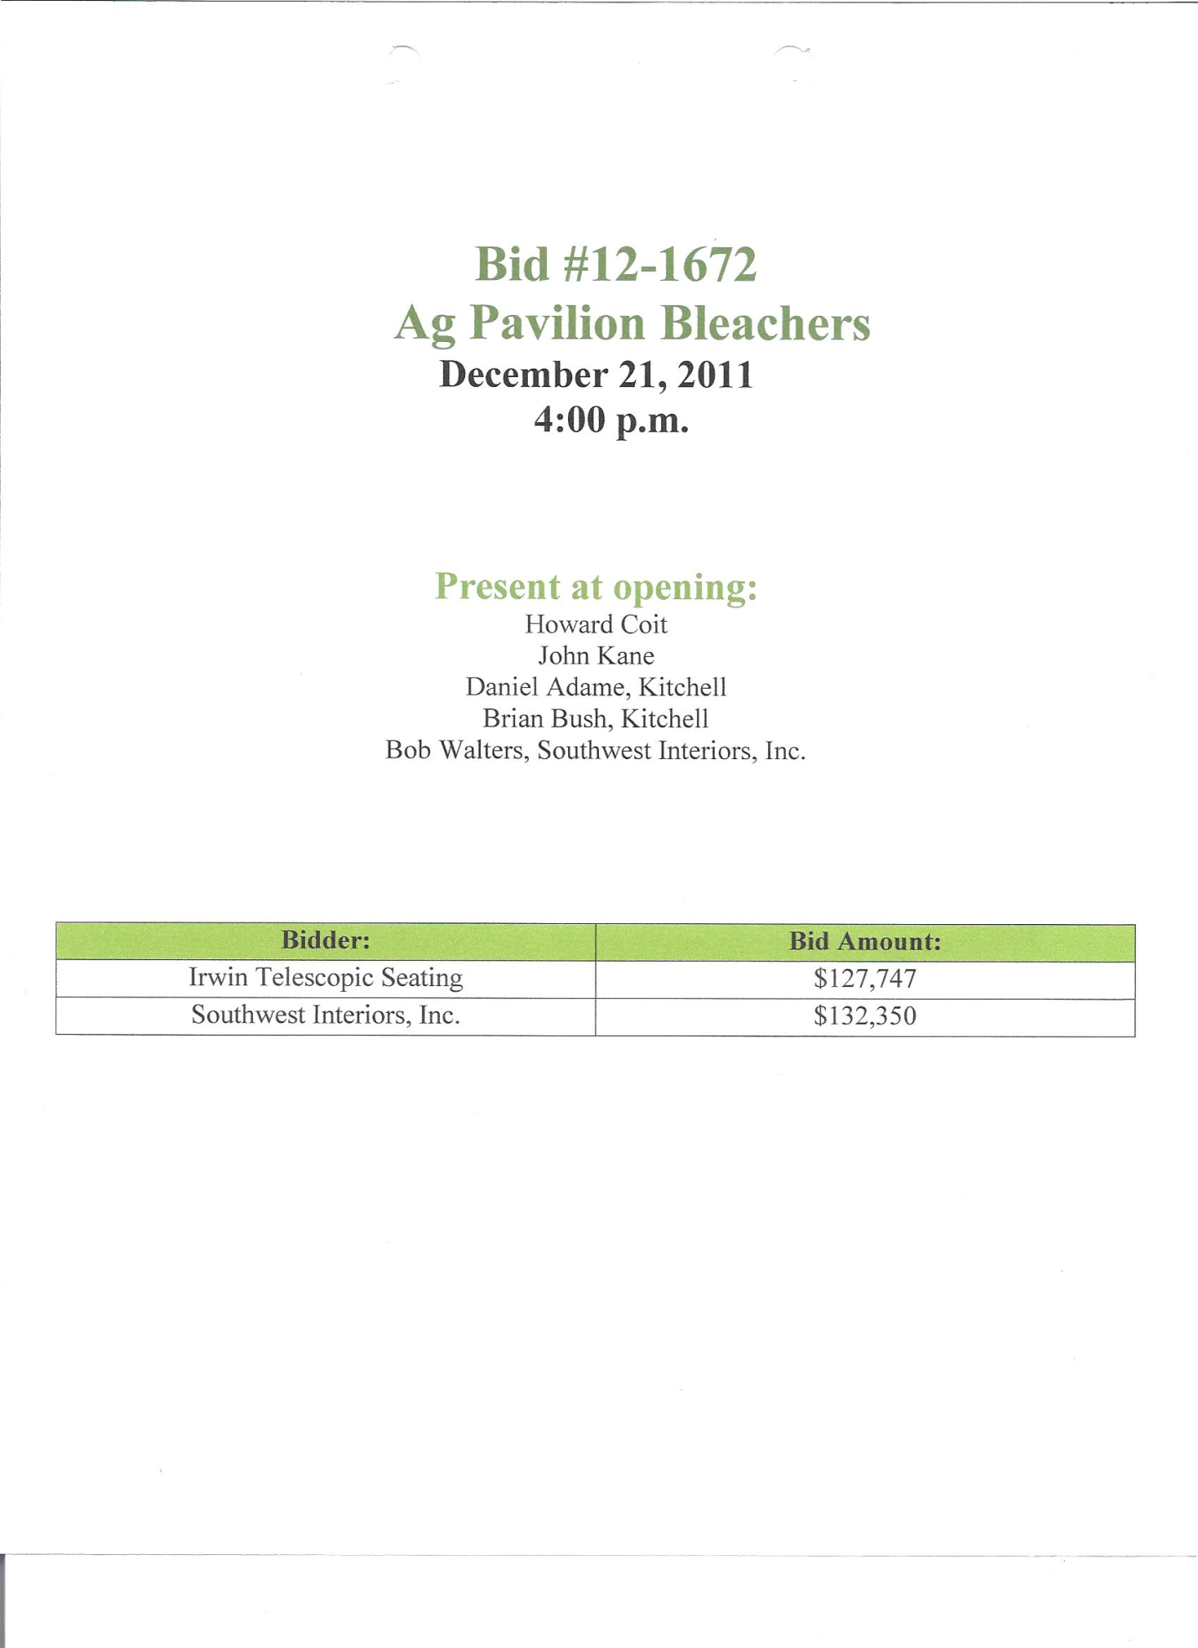

**NOTIFICATION**

**Due to incorrect license from Irwin Telescopic Seating their bid will not be considered.**

**Southwest Interiors, Inc listed one sub contractor: Tutt Construction out of San Diego.**