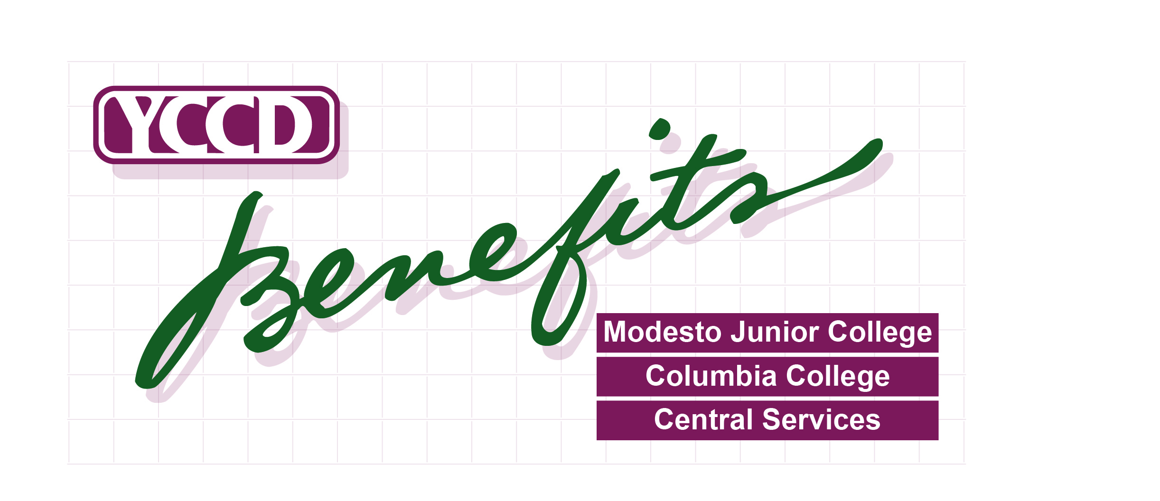

DATE: July 22, 2019 CORRECTED LETTER

TO: YCCD Retirees
FROM: YCCD - Benefits Office
SUBJECT: Annual Benefits Open Enrollment

Annual Open Enrollment Period
Monday, August 5, 2019 through Monday, August 26, 2019
NOTE: No action is necessary if you do not wish to make any changes.

What is Open Enrollment?
Once a year, the District’s medical plans provide for an annual “Open Enrollment Period” during which any enrolled retiree may change their medical plan and add or terminate any eligible dependents (some documentation may be required). If you have not already enrolled in a medical plan as a retiree, you may not enroll at this time.

Open Enrollment Meeting Schedule
A SISC representative will be available to answer questions at the following meetings:
Deadline to Submit Changes: Monday, August 26, 2019

All forms are due in the Benefits Office no later than 5:00 pm
Date | Time/Location
Monday, August 5, 2019  10:30 am – 11:30 am | Yosemite Community College District Office - Board Room  PRESENTATION STARTS AT 10:30am
Tuesday, August 6, 2019  9:30 am – 3:00 pm | Columbia College - Manzanita Multi-Purpose Room

Important clarifications on verbiage used in this letter and supporting attachments:
*Retirees (including any Spouse and/or Children) who are NOT Medicare eligible are included in the “UNDER 65” group options.
*Retirees who are NOT Medicare Eligible with a spouse &/or dependent who DOES have Medicare A/B – all parties remains in the “UNDER 65” group options.
* Retirees who ARE Medicare Eligible with a spouse/dependent who is NOT Medicare eligible are included in the “UNDER 65” group options. Retiree is responsible for part of the medical premium.
*Retirees who ARE eligible for Medicare A/B (AND if spouse/dependents ALL have Medicare A/B) are included in the “Over 65” group options. Any Medicare eligible parties must provide a copy of their Medicare A/B card to YCCD Benefits Office and may be required complete a separate enrollment package as required by provider.
KAISER EXCEPTION: Any covered party (retiree or spouse or dependent) who has Medicare A/B must enroll in the Kaiser Permanente Senior Advantage Program.
CONTINUED ON BACK
Page 1 of 2
General health plan provisions have not changed for the 2019-20 year

MEDICAL PLAN OVERVIEW - EFFECTIVE OCTOBER 1, 2019

PLAN OPTIONS FOR “UNDER 65” RETIREE GROUPS
NOT available for “Over 65” Retiree Groups as defined on Page 1

Kaiser HMO
- $30 Office Visit Copay: No Co-Insurance payments
- Medical out of pocket maximum: $1,500-individual/$3,000-family
Blue Shield PPO Plan 80-G
- $30 Office Visit Copay; 20% Co-Insurance after deductible ($500-individual /$1,000-family)
- Medical out of pocket maximum: $2,000 individual/$4,000 family includes deductible, co-pays and co-insurance
Blue Shield PPO Plan 80-C
- $20 Office Visit Copay; 20% Treatment Co-Insurance after deductible ($200 individual/$500 family)
- Medical Out of pocket maximum: $1,000-individual/$3,000- family; includes deductible, co-pays and co-insurance
Blue Shield PPO Plan 90-G
- $20 Office Visit Copay; 10% Treatment Co-Insurance after deductible ($500 individual/$1,000 family)
- Medical Out of pocket maximum: $1,000-individual/$3,000- family; includes deductible, co-pays and co-insurance
Blue Shield PPO Plan 100-D
- $30 Office Visit Copay; No Co-Insurance after deductible ($300-individual/$600-family)
- Medical out of pocket maximum: $1,000-individual/$3,000-family; includes deductible and office visit copays

PLAN OPTIONS FOR “OVER 65” RETIREE GROUPS
Available when ALL COVERED PARTIES have Medicare A/B
Kaiser Permanente Senior Advantage (ANY party with Medicare A/B must enroll)
- $0 Office Visit Copay: No Co-Insurance payments
- Medical out of pocket maximum: $1,500-individual/$3,000-family
Blue Shield PPO Plan 100-G (previously incorrectly listed as 100A)
- $20 Office Visit Copay; No Co-Insurance after deductible ($500-individual/$1,000-family)
- Medical out of pocket maximum: $1,000-individual/$2,000 2-party/3,000-family; includes deductible and office visit copays
Blue Shield PPO Plan 100-A
- $0 Office Visit Copay; No Deductible
- Medical out of pocket maximum: $1,000-individual/$2,000 2-party/3,000-family; includes deductible and office visit copays
Review plan materials including the 2019-20 Retiree Monthly Premium Rates to determine your monthly premiums (if applicable). You may access Benefits plan information and forms on our website at http://www.yosemite.edu/benefits/.

If you are paying toward Medical, Dental or Vision premiums, all rate changes go into effect October 1st. Make sure your payments reflect the new rates.

Deadline to submit Open Enrollment forms is Monday, August 26, 2019 at 5:00 pm. You may submit completed forms at Open Enrollment meetings.

You may contact the Benefits Office at (209) 575-6981 or by e-mail.
Peggy Freitas: freitasp@yosemite.edu or Lori Smith at smithl@yosemite.edu .

Page 2 of 2

